|  |  |
| --- | --- |
|  | image004.jpg |

Redbox Bing Bar app specs

Specifications Document

*Version 1.0*

**DOCUMENT HISTORY**

|  |  |  |  |
| --- | --- | --- | --- |
| **Version** | **Date** | **Description** | **Author** |
| 1.0 | 06/02/2011 | Initial draft creation. | Viju Hullur |
|  |  |  |  |
|  |  |  |  |
|  |  |  |  |
|  |  |  |  |

**DOCUMENT APPROVAL**

|  |  |  |  |  |
| --- | --- | --- | --- | --- |
| **Version** | **Date** | **Approver** | **Role** | **Comment** |
|  |  | Scott Sisil | PDM – Open API |  |
|  |  | Saad Rehmani | Director – Software Architect |  |
|  |  | Chris Rudolphi | Software Architect |  |
|  |  | Bart Dolega | Director – Software Development |  |
|  |  | Kishore Adabala | Lead - QA |  |
|  |  |  |  |  |

**TABLE OF CONTENTS**

1 INTRODUCTION 4

1.1 Project Background 4

2 Bing Bar App – In SCOPE 5

3 Out of Scope 6

4 Assumptions and Dependencies - 6

5 Redbox Bing Bar – Sample Screens 7

# 1 INTRODUCTION

## 1.1 Project Background

The purpose of Redbox Bing Bar app is to increase Redbox brand name awareness in the market place. Microsoft built the Bing Bar app platform to allow partners to build apps (similar to mobile apps).

Below is the description from Microsoft on Bing Bar:

The Bing Bar team built Bing Bar based on this mission statement: "We want the toolbar to be useful, unobtrusive, and anticipative. It serves your needs, gets out of the way when you don't need it, and gives you little magical moments when it presents you with information." Bing Bar apps provide quick, at-a-glance access to information, entertainment, or assistance while the user also does other activities on the web.

The Bing Bar app platform lets partners extend Internet Explorer with rich, interactive apps and tools. Unlike a web page, the Bing Bar travels with the user. This means apps can be aware of the user’s activities and intentions. This new app platform resides between traditional, static links found on traditional browser toolbars, and the full presentation of a web site visit. A Bing Bar app has new tools to determine a user’s goal, including access to data such as the browser URL, DOM, and search history that it can use to determine the user’s intent, help accomplish the user’s goal, or send the user to a web page. Bing Bar apps can help users stay connected to personal web services, and stay informed about topics of interest.

Bing’s SDK document is location:

<https://boxoffice.redbox.com/digital/Shared%20Documents/Open%20API/z.%20Bing%20Bar%20App/Bing%20Bar%207.0%20SDK%20-%20DRAFT.DOCX>

Bing’s Human Interface document is location:

<https://boxoffice.redbox.com/digital/Shared%20Documents/Open%20API/z.%20Bing%20Bar%20App/Bing%20Bar%207.0%20Human%20Interface%20Guidelines.docx>

# 2 Bing Bar App – In SCOPE

For Bing Bar Release 1, following features will be implemented

|  |  |  |
| --- | --- | --- |
| **#** | **Feature Description** | **Corresponding Redbox API to use** |
| **Movies** | | |
| 1 | Allow the user to browse redbox movies.  Sort by: Release Date (desc) | Products/movies/default |
| 2 | Allow the user to filter browsable redbox movies by –  Genres: Action, Comedy, Drama, Family, Horror  Format: Both, DVD, Blu-ray  Ratings: All, G, PG, PG-13, R, NR  Sort By: Release Date(default), Titlename | Products/movies/default |
| 3 | Allow the user to browse redbox top 20 list for ‘past 7 days’ or ‘past 30 days’ | Products/movies/top20?p=*<period>* |
| 4 | Allow the user to browse redbox coming soon movies | Products/movies/comingsoon |
| 5 | Allow the user to search for specific product by typing in movie title (full or partial)  Question: Should the app support predictive search results and populate the movie titles name as they match? | Products/movies/search?titlename = <> |
| 6 | Navigate the user to redbox.com’s movie details page, whenever user clicks on ‘Rent’ or ‘Find’ from a specific movie  Note: We need new omniture codes to track customers being routed from Bin Bar app |  |
| **Stores** | | |
| 7 | Allow the user to view nearby redbox stores on Bing map. The map should display max 50 stores within 50 mile radius  Assumption: User’s lat/long is known | Stores/search?lat=<>?long=<> |
| 8 | Allow the user click on redbox store to view the store details such as Client’s name, address | Stores/storeguid=<> |
|  |  |  |
|  |  |  |

# 3 Out of Scope

For release 1 following features are out of scope.

* Provide customer to login using redbox (or third party) user credentials
* Provide inventory search for a store location based on user’s lat/long, assuming user lat/long is available.
* Provide inventory search for a movie title based on user’s lat/long, assuming user lat/long is available.
* Provide secure customer access to customer profile information
* Provide customer’s favorite kiosks
* Provide ability for a customer to reserve a movie at a specific kiosk
* Provide ability for a user to play trailer if available

# 4 Assumptions and Dependencies -

1. Redbox APIs developed in Open API release 1 and 2 will be utilized. The API documentation is located at -

https://boxoffice.redbox.com/digital/Shared%20Documents/Forms/AllItems.aspx?RootFolder=%2fdigital%2fShared%20Documents%2fOpen%20API&FolderCTID=&View=%7b41A2990A%2dCA40%2d48AC%2d9EAB%2d3C1014BCE2AB%7d

1. Bing Bar app can supply user’s lat and long to show nearby stores.

# 5 Redbox Bing Bar – Sample Screens

Launch redbox app/Browse Movies:

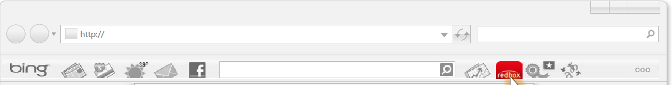

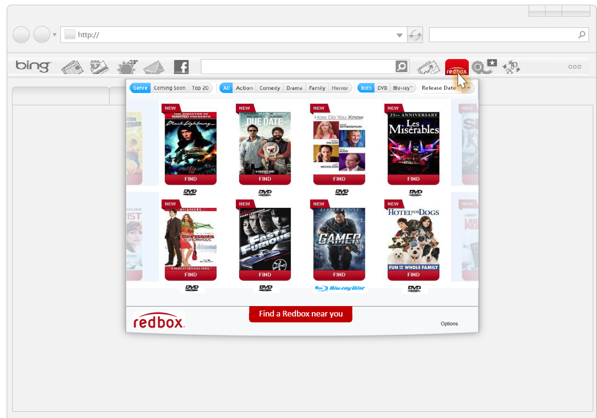

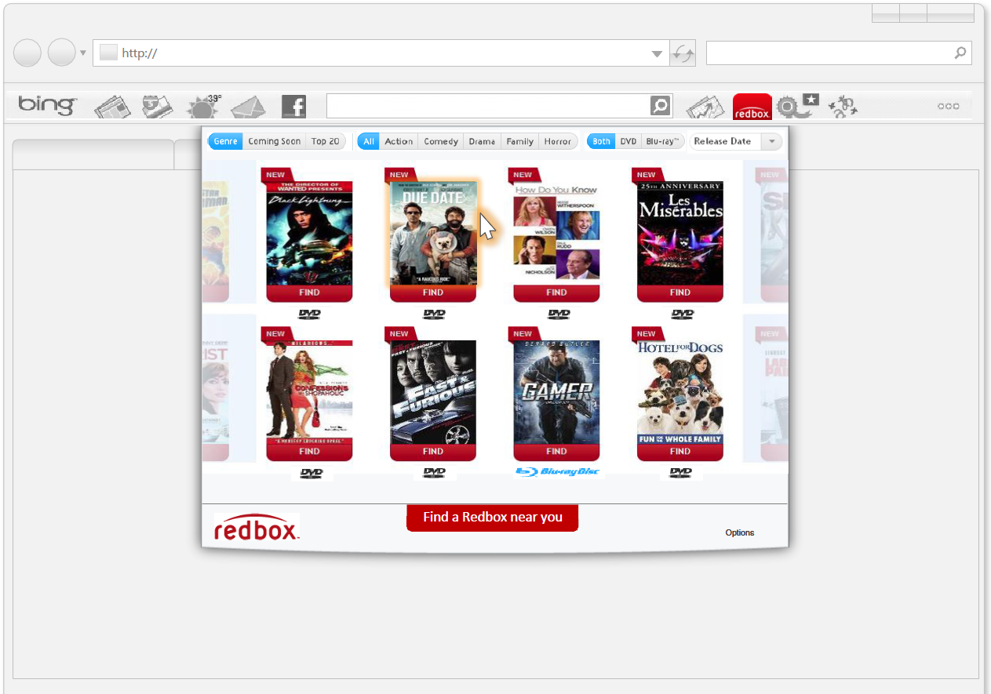

**Store Search:**

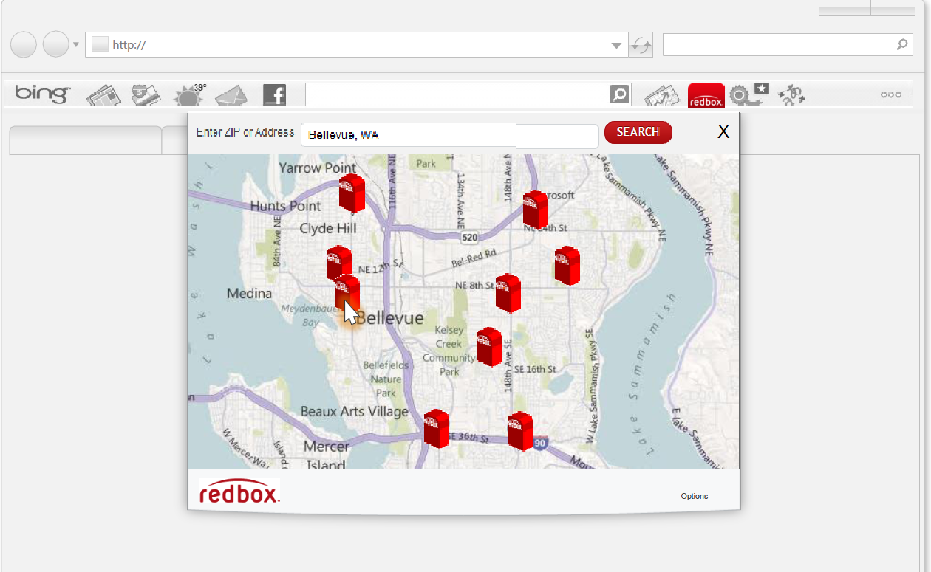

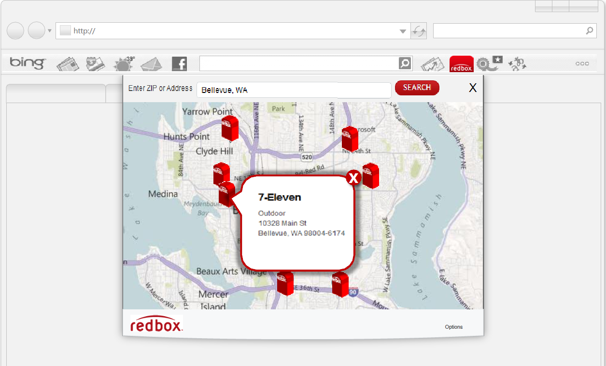

**Movie search:**

